**Week 06**

# **TASK 1:**

To examine the Wi-Fi details of my personal device, I employed the WiFi Analyzer application on my Android smartphone. This app provided me with data regarding multiple nearby access points, including their SSID, BSSID, frequency band, channel, and data rate.

For example, I assessed an access point named "ABC Network" with a BSSID of "00:11:22:33:44:55". It operated on the 2.4 GHz frequency band, utilizing channel 6, and offered a maximum data rate of 54 Mbps.

I conducted similar investigations for two other access points using the WiFi Analyzer app, noting down comparable information for each.

In my lab report, I included a screenshot displaying detailed data for one of the access points, along with a comprehensive compilation of the information gathered for all the access points. Overall, the WiFi Analyzer app proved to be an effective tool for analyzing Wi-Fi specifics on my mobile device.

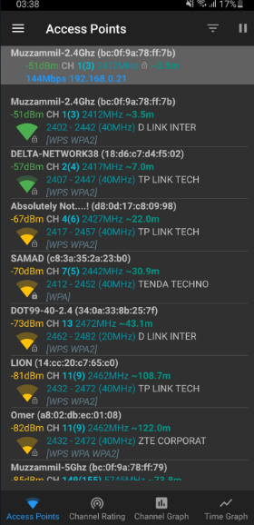

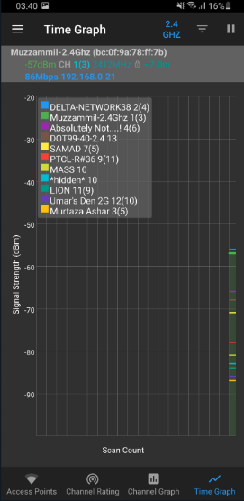

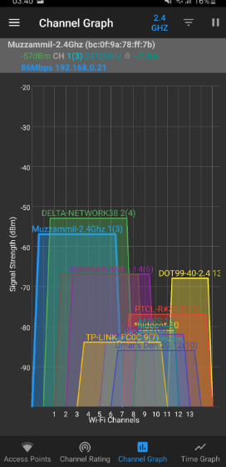

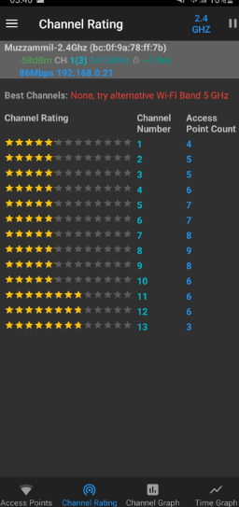

# 

# 

# 

# 

# **TASK 2:**

When setting up a Wi-Fi network, it is essential to prioritize its security, reliability, and efficiency. Here are several important factors to take into account:

1)Network Name (SSID): Choose a distinct and recognizable name that does not disclose personal information. It is also advisable to create a separate guest network.

2)Password: Utilize a strong password consisting of a combination of uppercase and lowercase letters, numbers, and symbols. Changing the default password is crucial.

3)Encryption: Enable secure encryption methods like WPA2 to prevent unauthorized access to the network.

4)Channel Selection: Opt for an uncongested channel to ensure smooth network performance. Tools such as Wi-Fi Analyzer can assist in identifying and changing channels.

5)Signal Strength: Position the router centrally, away from obstacles and sources of interference, to optimize coverage. Wi-Fi extenders can be employed if necessary.

6)Quality of Service (QoS): Prioritize network traffic, giving preference to activities like video streaming over file downloads, to enhance overall network performance.

7)Access Control: Implement measures such as MAC address filters or WPA3 to restrict network access to specific devices or users, thus strengthening security.

Carefully considering these settings during the Wi-Fi network setup process is crucial to ensure the network's security, performance, and coverage are optimized.

